**Classroom Activity: Push your code to GitHub repository.**

**Steps:**

1. **Prepare Your Website Files:**

* Ensure your website files (HTML, CSS, JavaScript, etc.) are organized in a folder structure on your computer.

1. **Drag and Drop to GitHub:**

* Navigate to your newly created repository.
* Locate the main code view section of your repository. It should display existing files (if any) or be empty.
* Drag all your website files and folders from your local directory and drop them directly into the GitHub code view section.

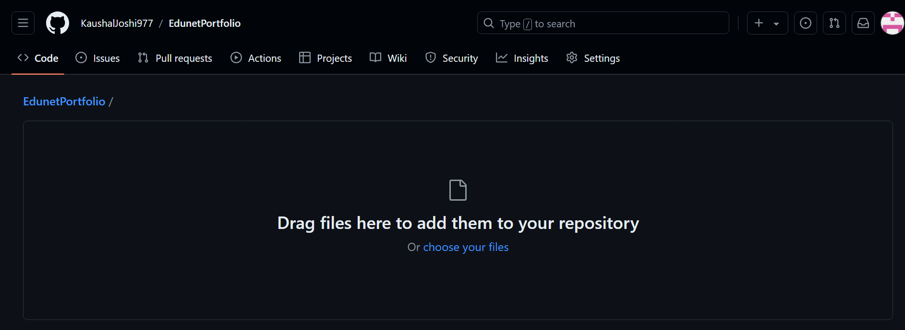

1. **Commit the Changes :**

* GitHub might automatically detect the uploaded files and display a commit message prompt.
* You can add a descriptive commit message (e.g., "Initial website files") and click "Commit changes" to create a snapshot of the uploaded files.

